LEASE MANAGEMENT

College Name : KG College of Arts and Science

Group project

TEAM ID : NM2025TMID23633

TEAM MEMBERS :

* Team Leader : NARMATHASHREE T
* Email: 2326kb29@kgcas.com
* Team Member : NISHANTH C
* Email: 2326kb29@kgcas.com
* Team Member : NITHISH S
* Email: 2326kb29@kgcas.com
* Team Member : NITHYA SREE
* Email: 2326kb29@kgcas.com

Project Description:

This project is focused on the development and implementation of a Lease Management System using Salesforce, designed to address the challenges of manual property lease tracking, tenant management, payment processing, and communication within the organization.The goal is to deliver a comprehensive solution that streamlines and automates various aspects of lease management, from contract creation to payment tracking, approval workflows, and reporting.

Through this project, we aim to enhance operational efficiency, data accuracy, and user experience for property managers, finance teams, and tenants. By leveraging Salesforce's powerful platform, we will create a solution that enables better tenant relationship management, ensures timely payments, and provides real-time visibility into key lease metrics. This will support the long-term goals of improving financial tracking, reducing administrative overhead, and scaling operations as the organization grows.

Objectives:

Business Goals:

1. Improve Operational Efficiency:

* Goal : Automate manual lease management processes to reduce administrative tasks, streamline workflows, and optimize timespent on routine tasks.
* Measure: Reduce the time spent on manual data entry and tenant communication by 30% within the first 6 months of implementation.

1. Enhance Data Accuracy and Centralization:

* Goal: Ensure accurate and up-to-date tenant, property, and payment data is centrally stored and accessible in Salesforce.
* Measure: Achieve 100% accuracy in property and tenant records within 3 months post-deployment, with real-time updates on lease statuses and payments.

3. Increase Rent Collection and Timely Payments:

* Goal: Automate payment reminders and overdue notifications to reduce late payments and improve rent collection efficiency.
* Measure: Reduce overdue payments by 25% within the first 6 months, and achieve a 95% on-time payment rate.

4. Improve Tenant Satisfaction and Communication:

* Goal: Improve tenant communication with automated emails for lease renewals, payment reminders, and other key events.
* Measure: Achieve a 20% improvement in tenant satisfaction scores related to communication and transparency (measured through surveys).

5. Improve Financial Visibility and Reporting:

* Goal: Provide real-time reports and dashboards to track property occupancy, lease expirations, overdue payments, and overall financial health.
* Measure: Achieve 100% adoption of real-time reports and dashboards by the finance and property management teams within 2 months of deployment.

DEVELOPMENT PHASE IN SALESFORCE:

Creating Developer Account:

By using this URL - <https://developer.salesforce.com/signup>

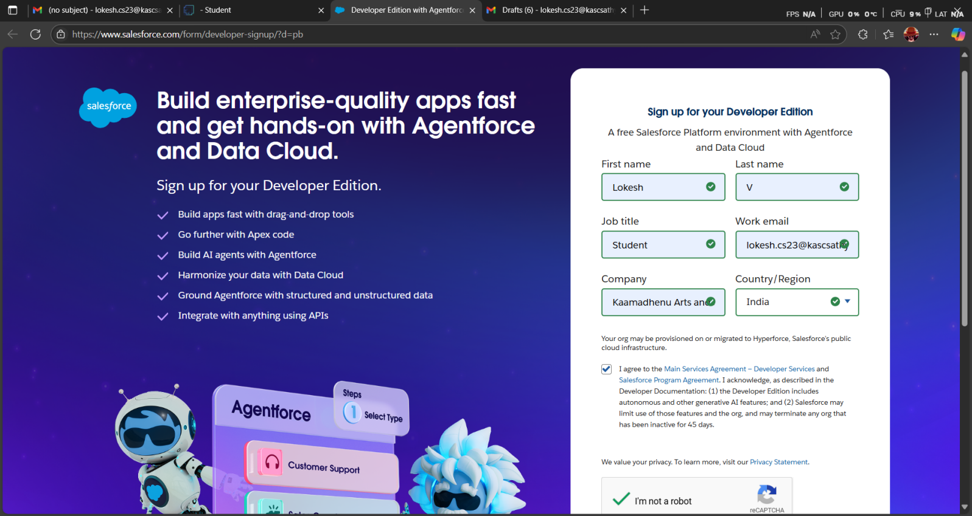

Account Activation

1. Go to the inbox of the email that you used while signing up. Click on the verify

account to activate your account. The email may take 5-10mins.



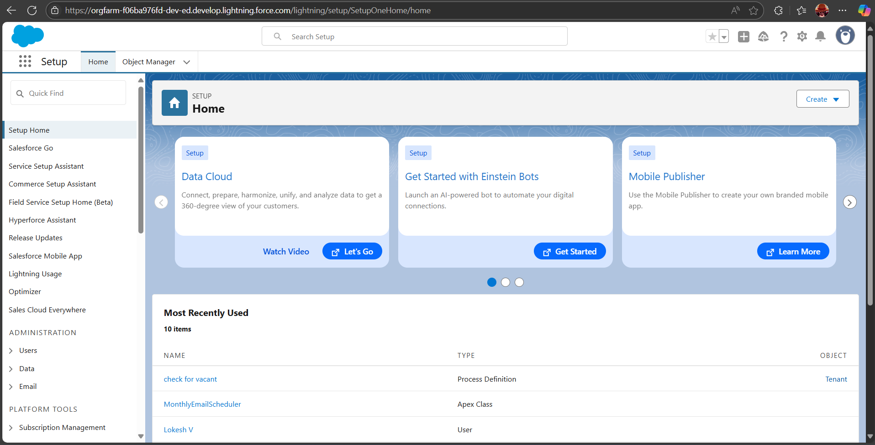

Salesforce Home Page

Created Objects :

* We need to create the objects in the name of Property, Tenant, Lease, Payment.

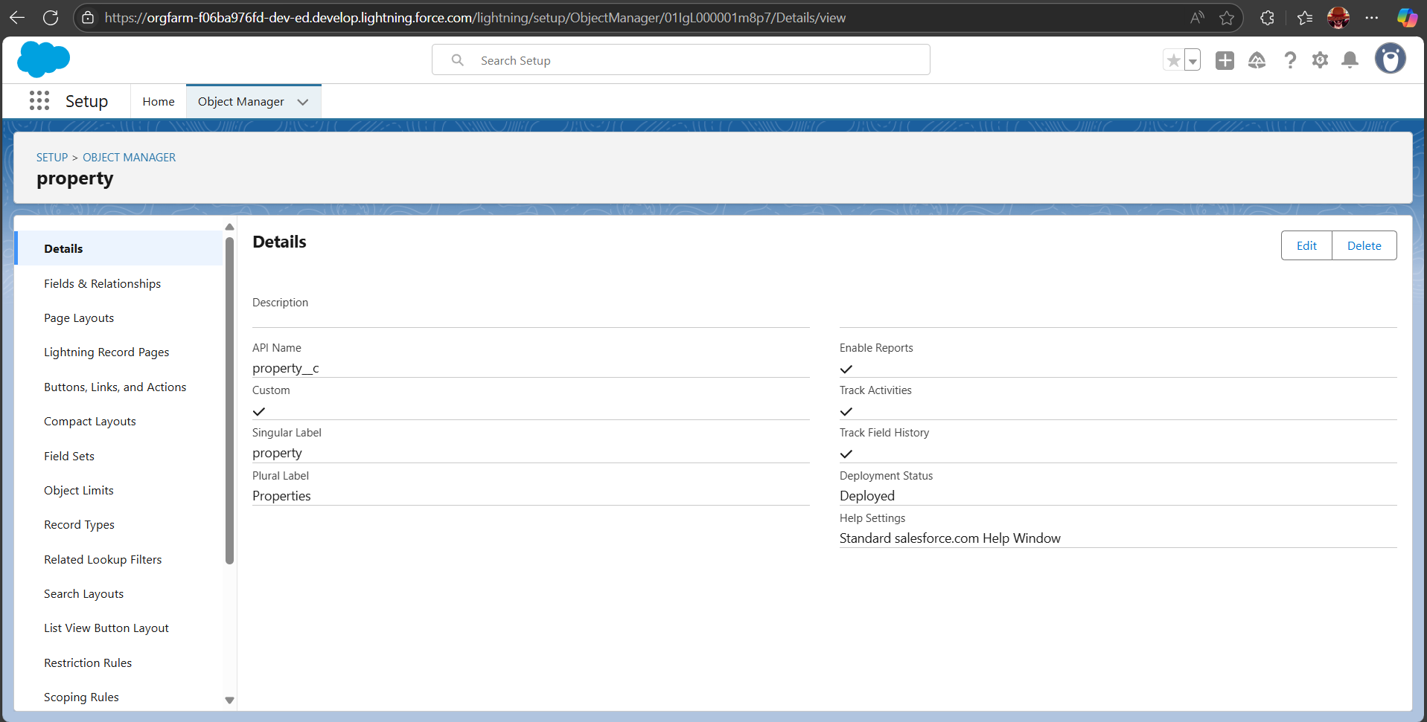

Property Object

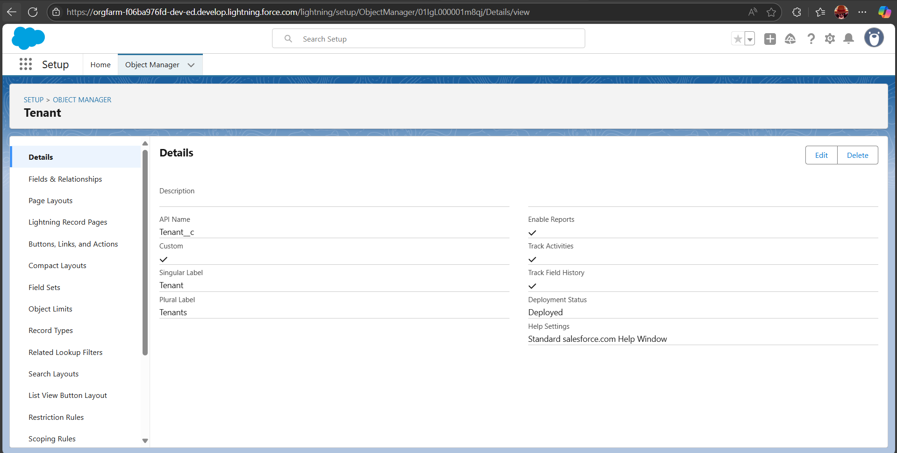

Tenant Object

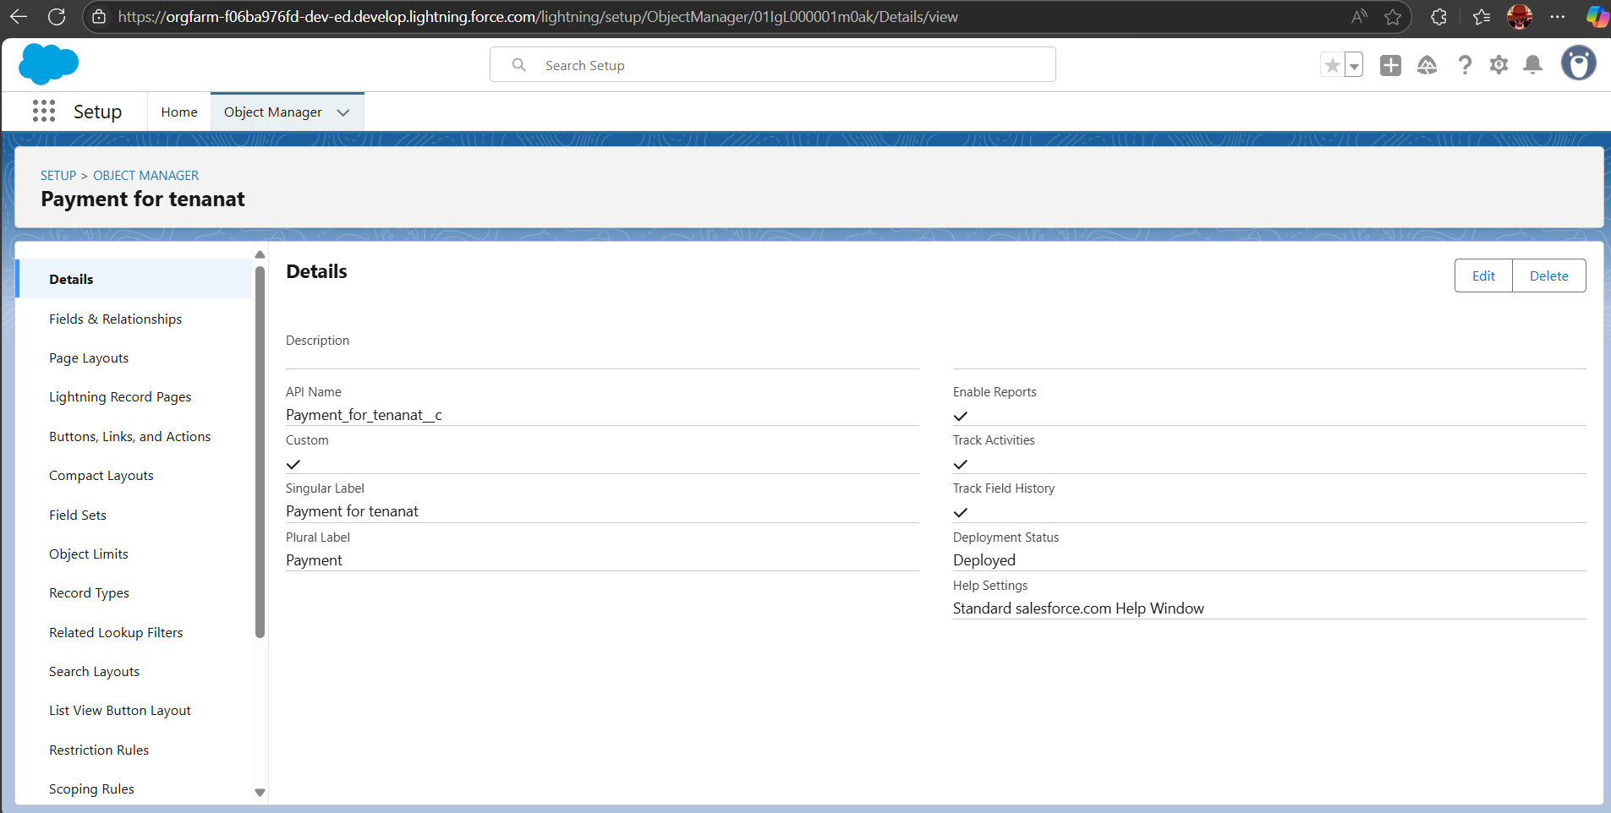

Payment for Tenant Object

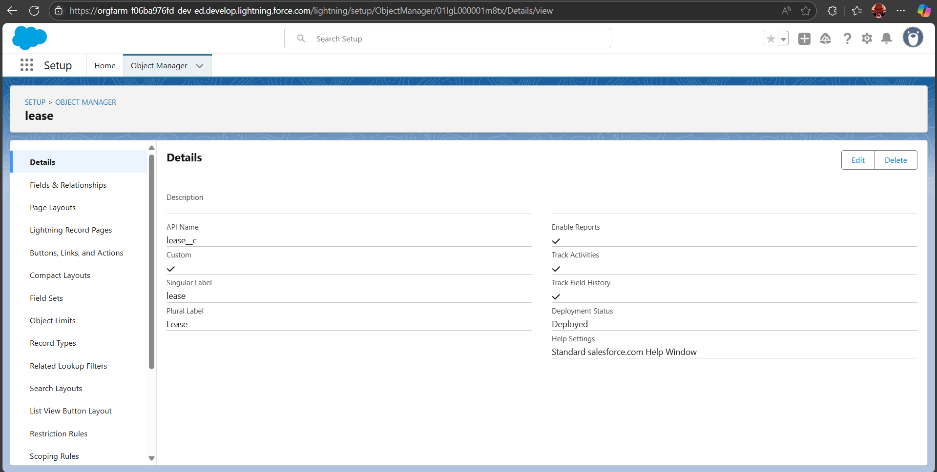

Lease Object

Tabs:

Creating a Custom Tabs:

* Create a Custom Tabs for those object we created already in the custom tabs section.

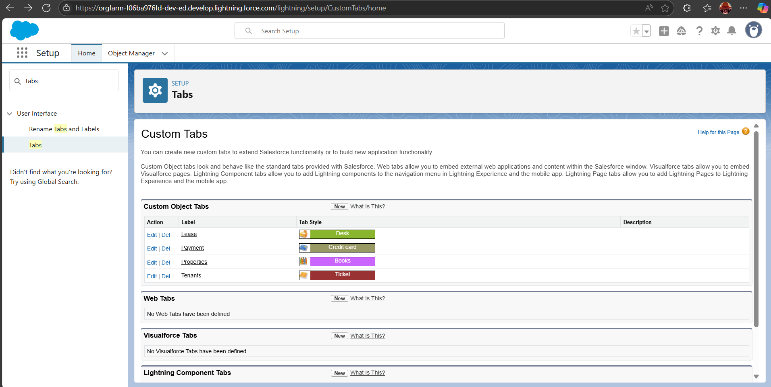

Custom Tabs for those four Objects

### Create a Lightning App:

* Create the lightning app in the App Manager and Click the New Lightning App Button then name it as Lease Management.

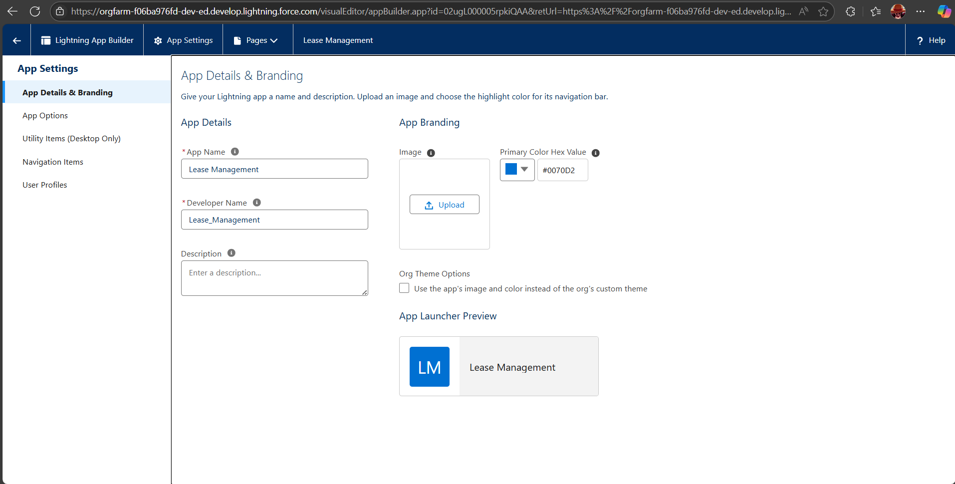

App Details & Branding

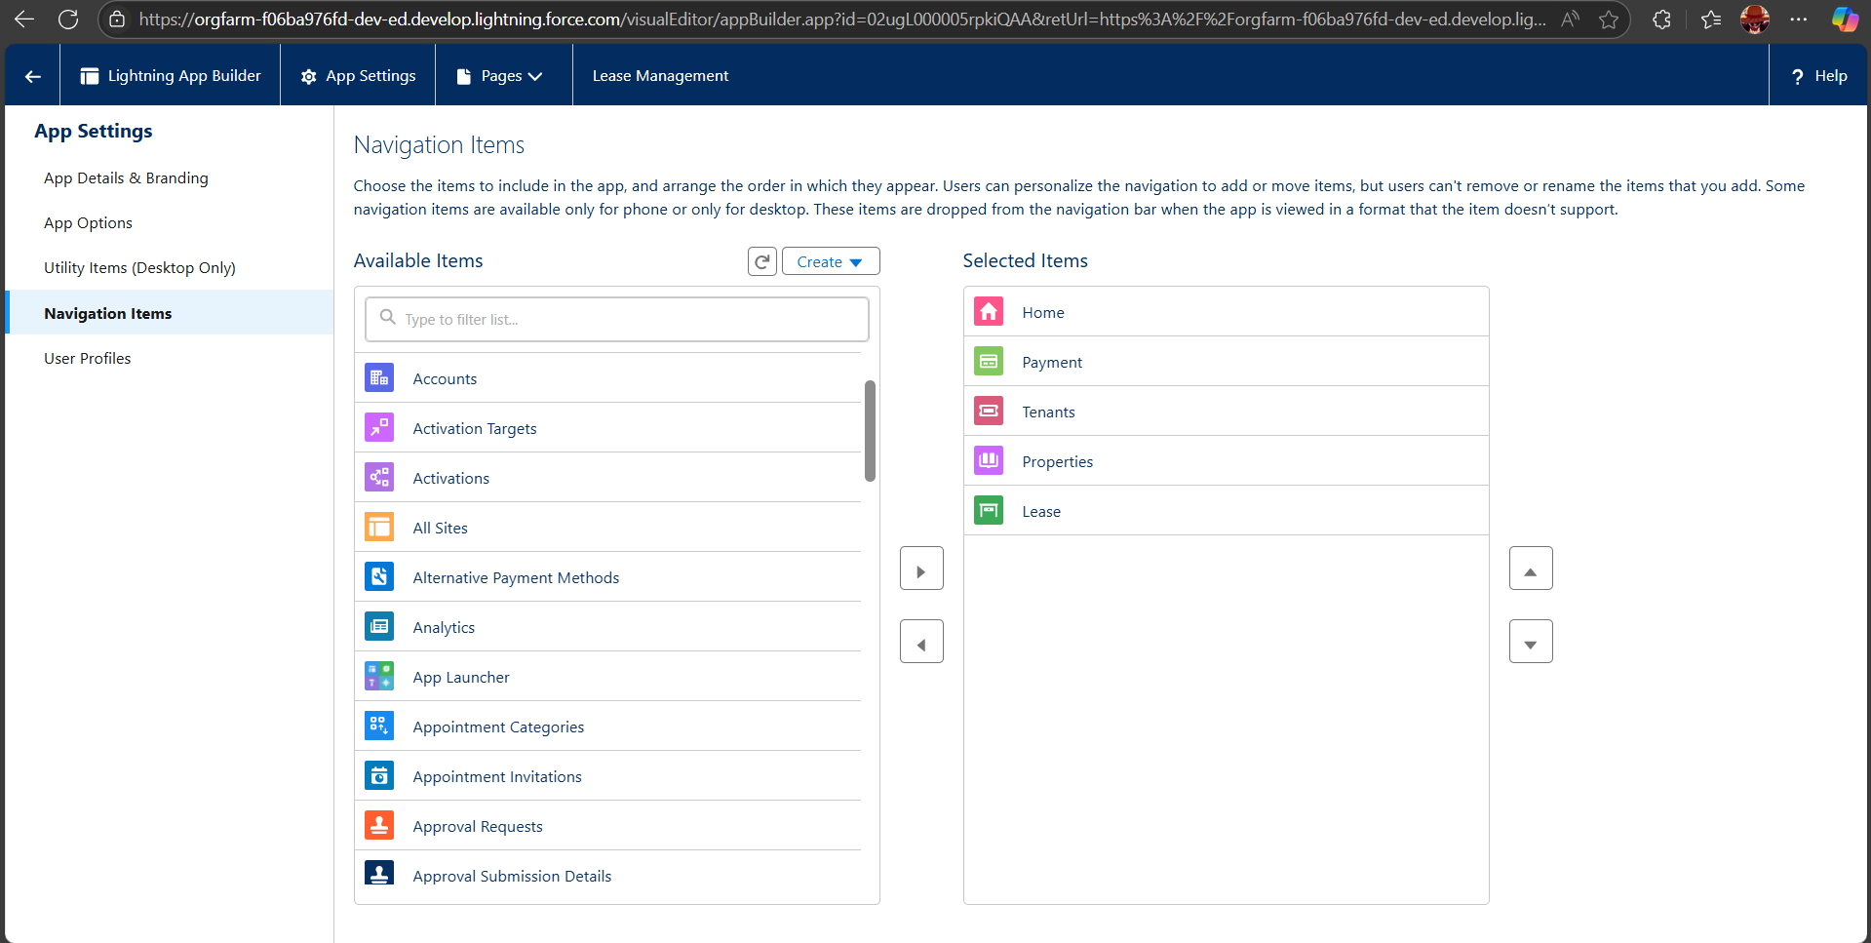

Navigation Items

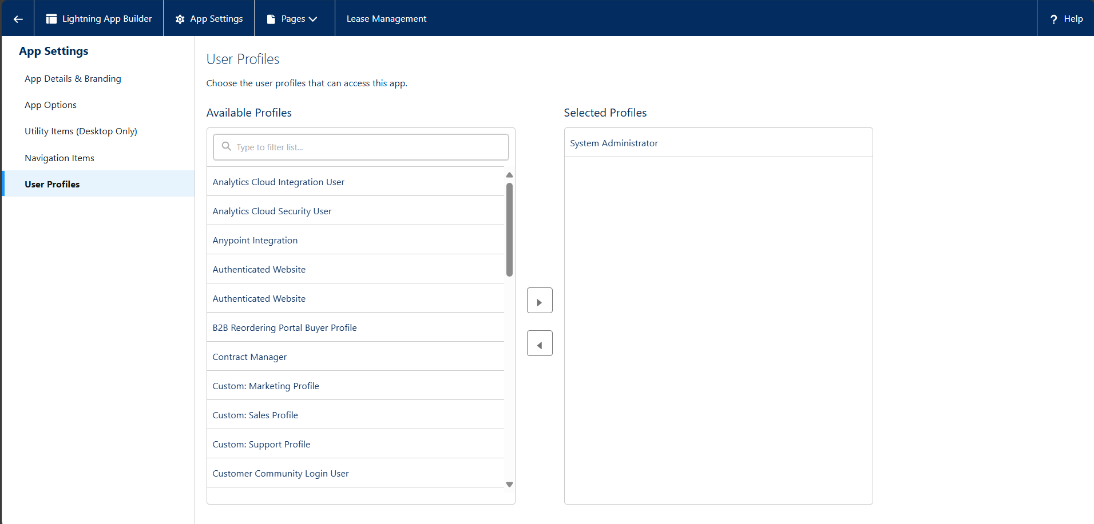

User Profiles

Fields:

* Created the fields in the Property, Tenant, Lease, Payment for Tenant objects.

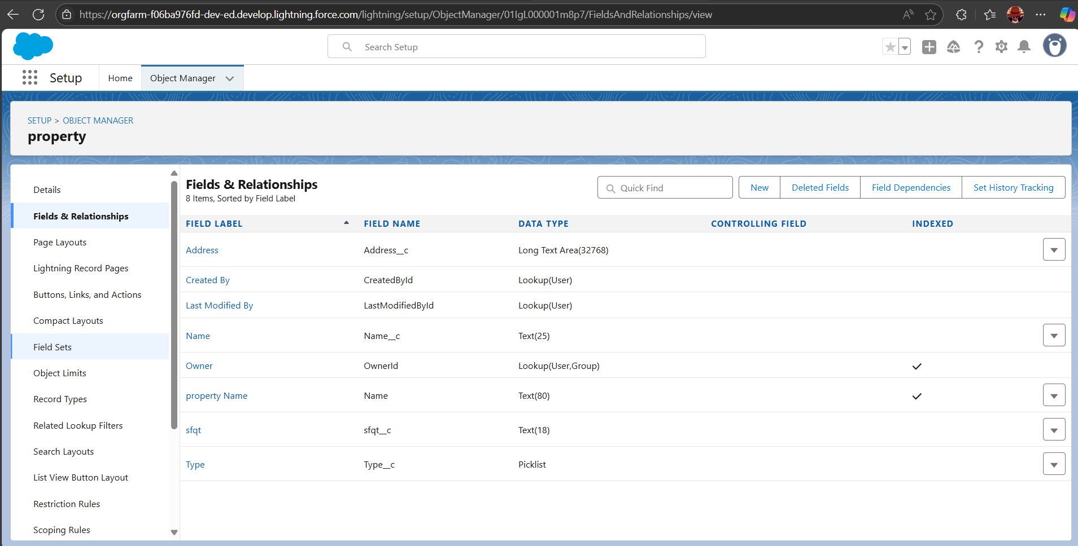

Created fields for the Property Object

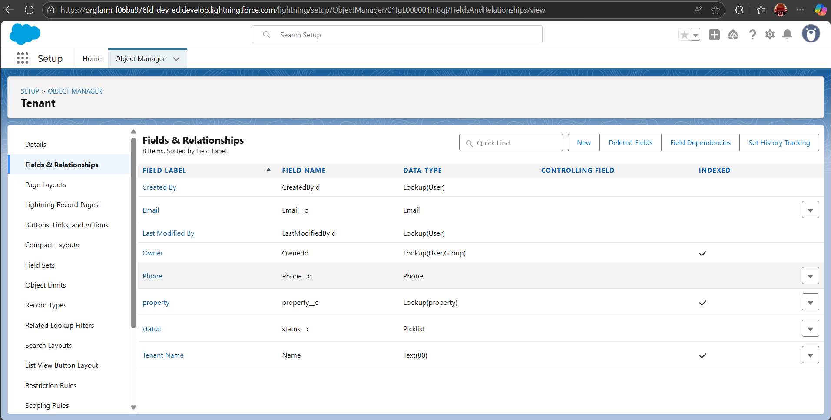

Created fields for Tenant Object

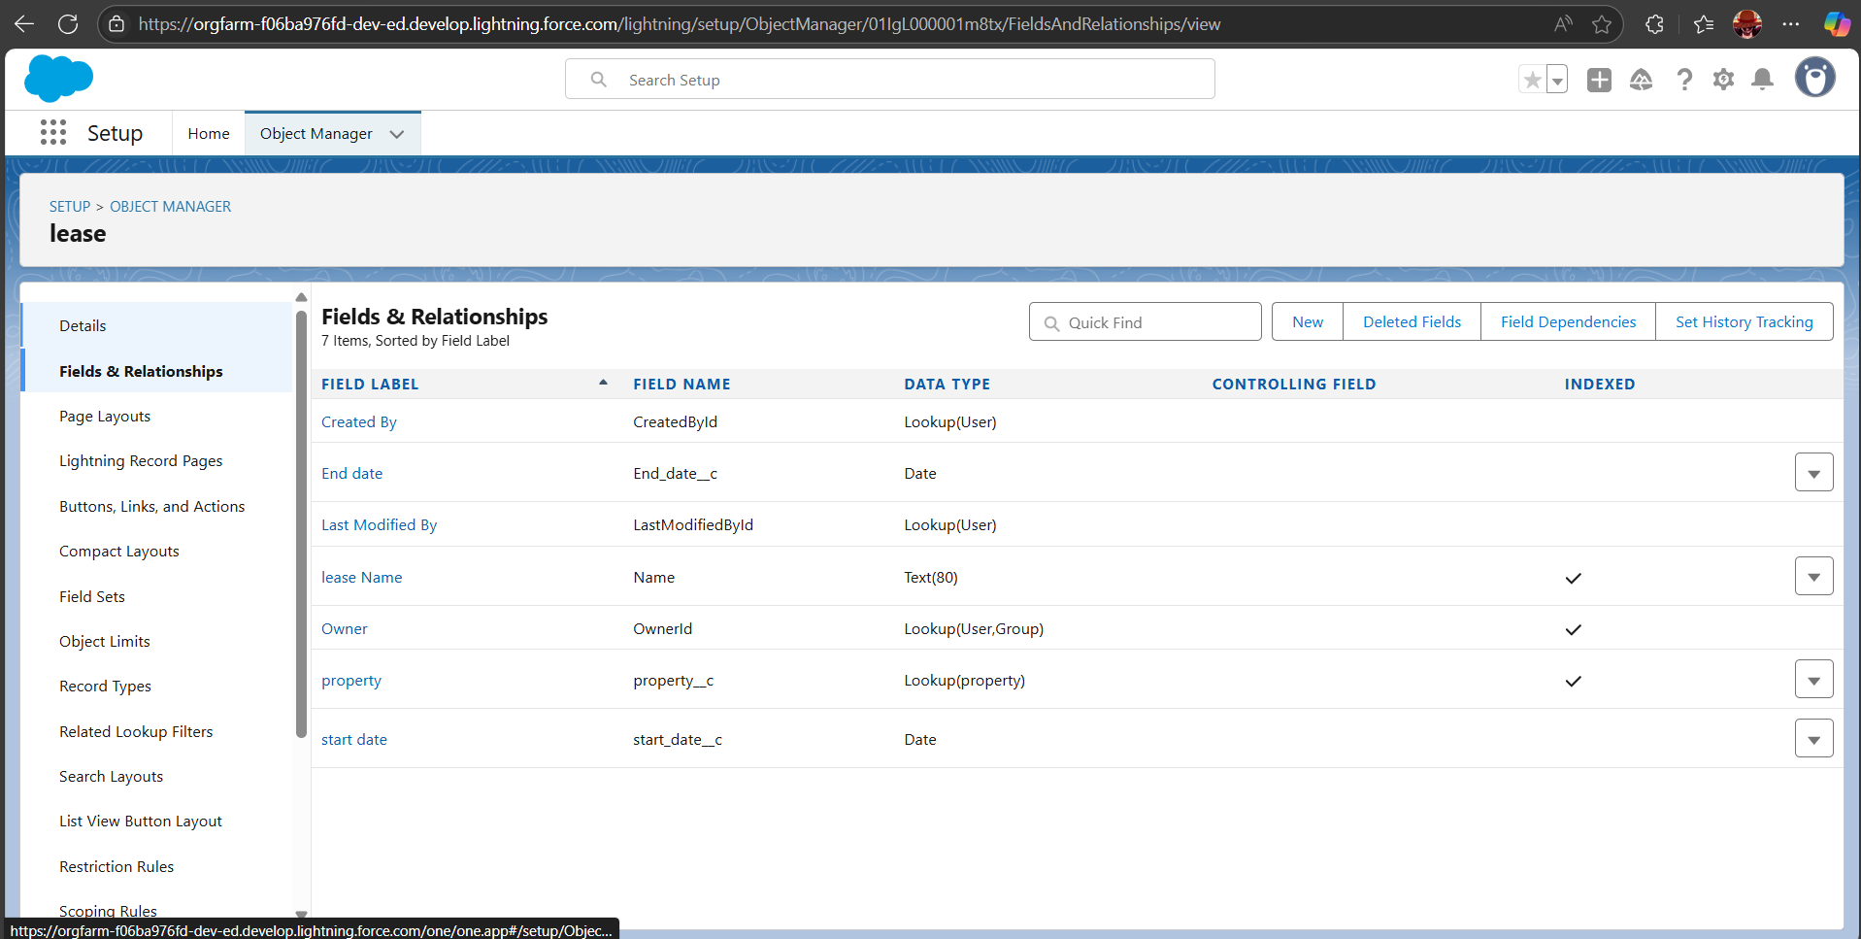

Created fields for Lease Object

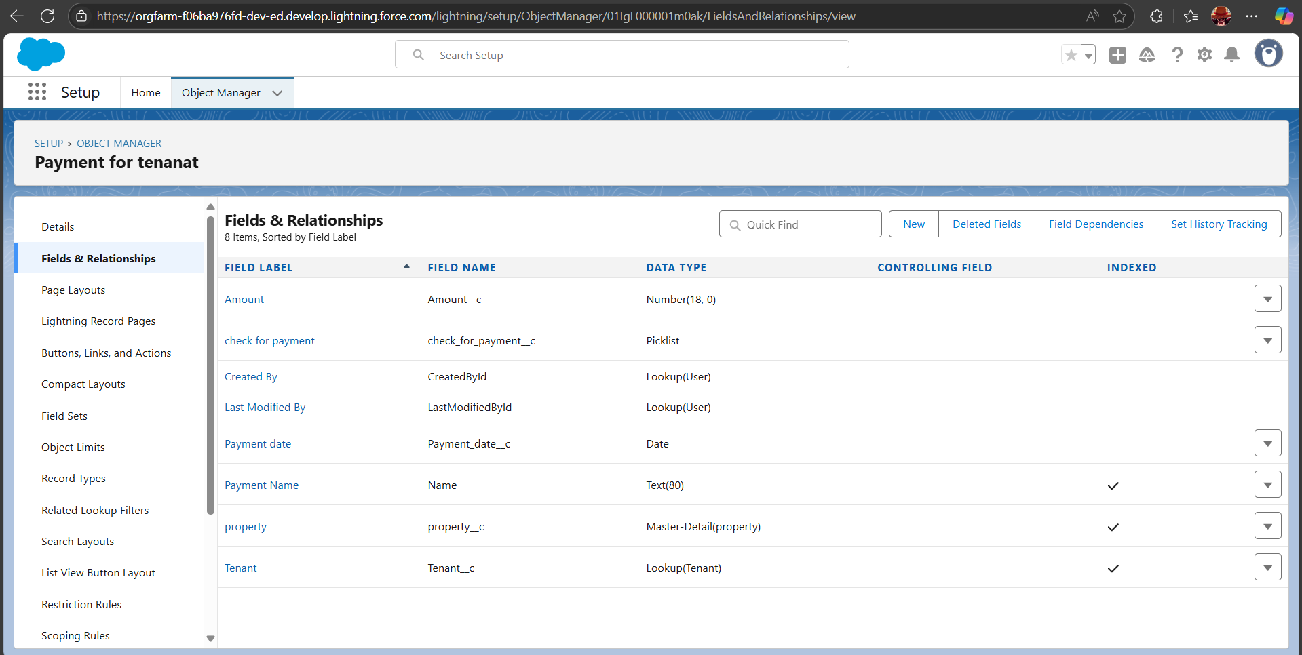

Created fields for Payment for Tenant Object

Validation Rule:

* To Create a Validation rule for the Lease Object.

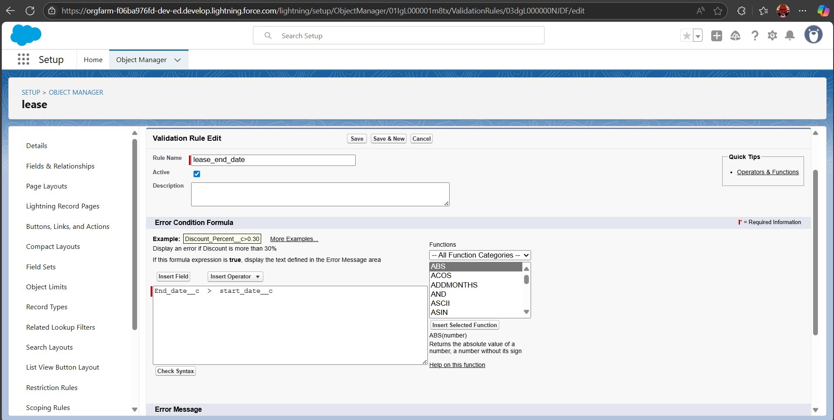

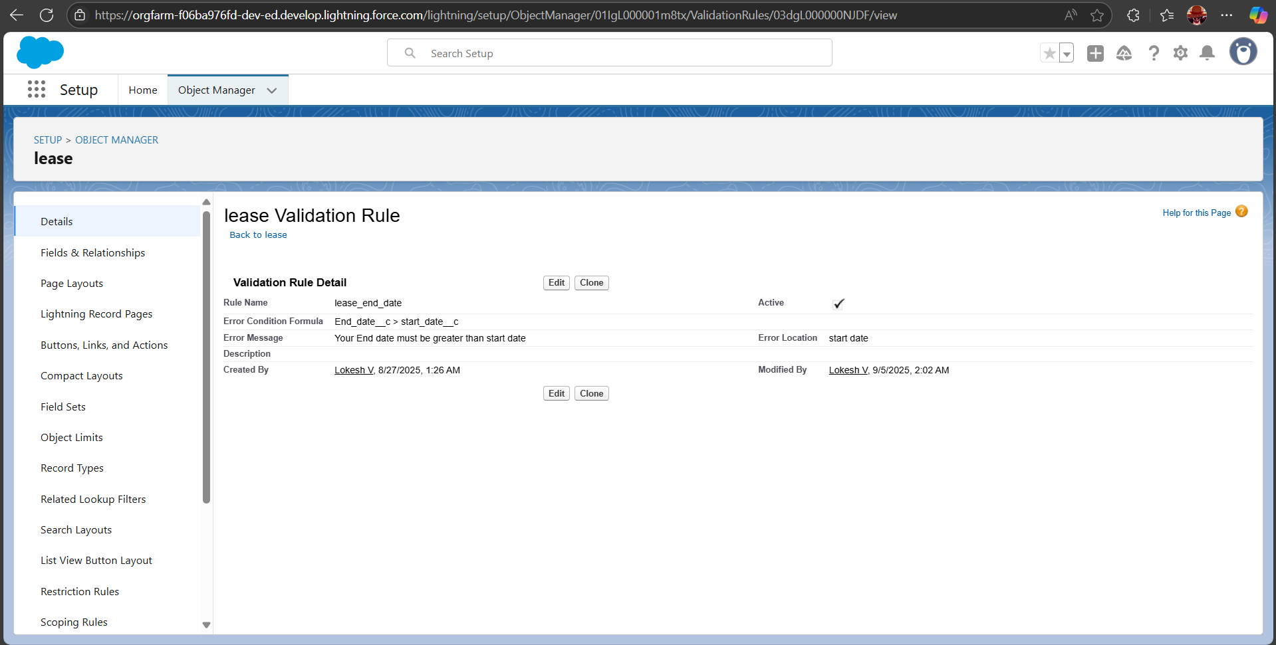

Email Templates:

* Created email templates for tenant leaving, Leave Approved,Rejection for leave , Monthly Payment and Successful Payment.

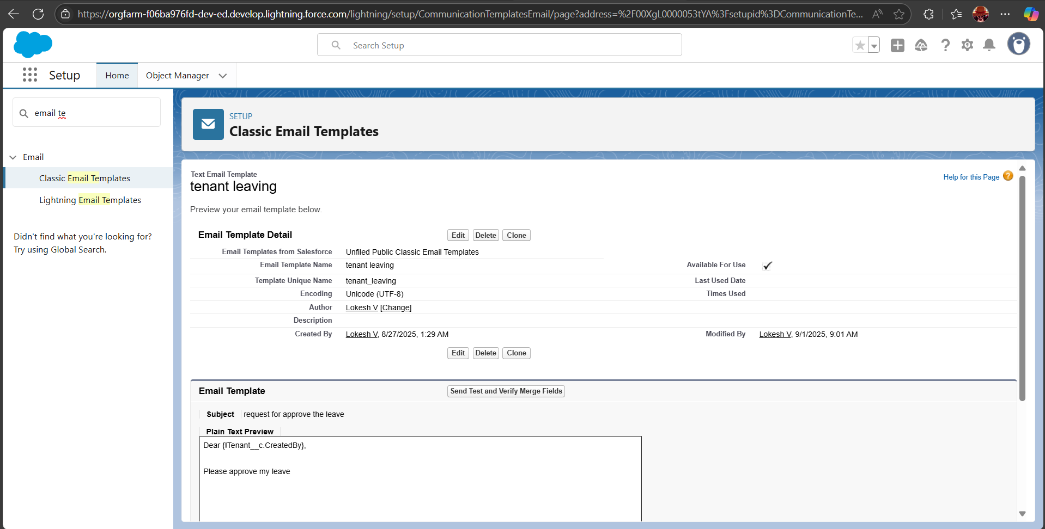

Tenant Leaving

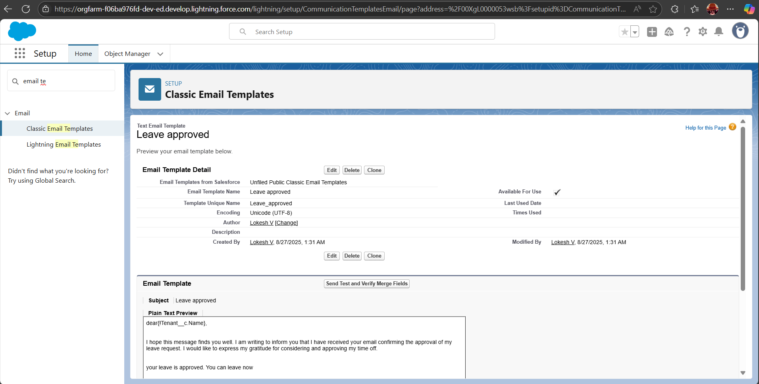

Leave Approved

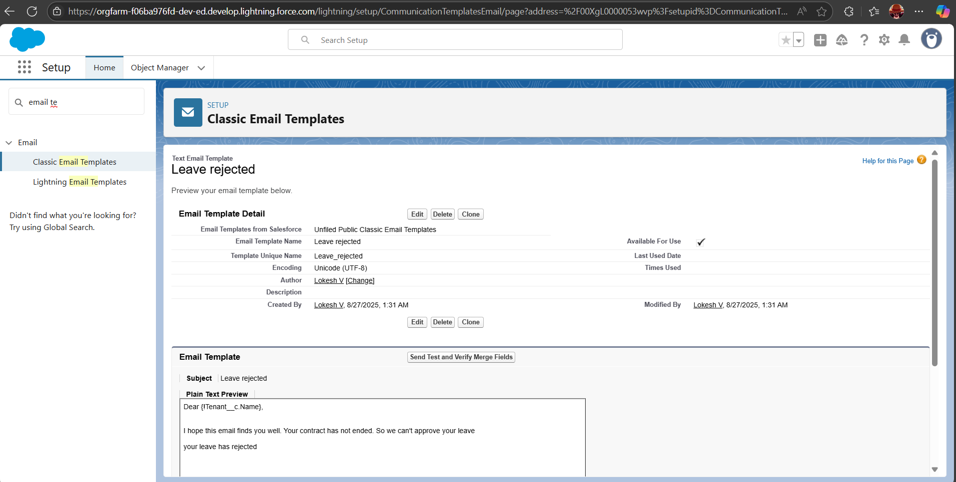

Leave Rejected

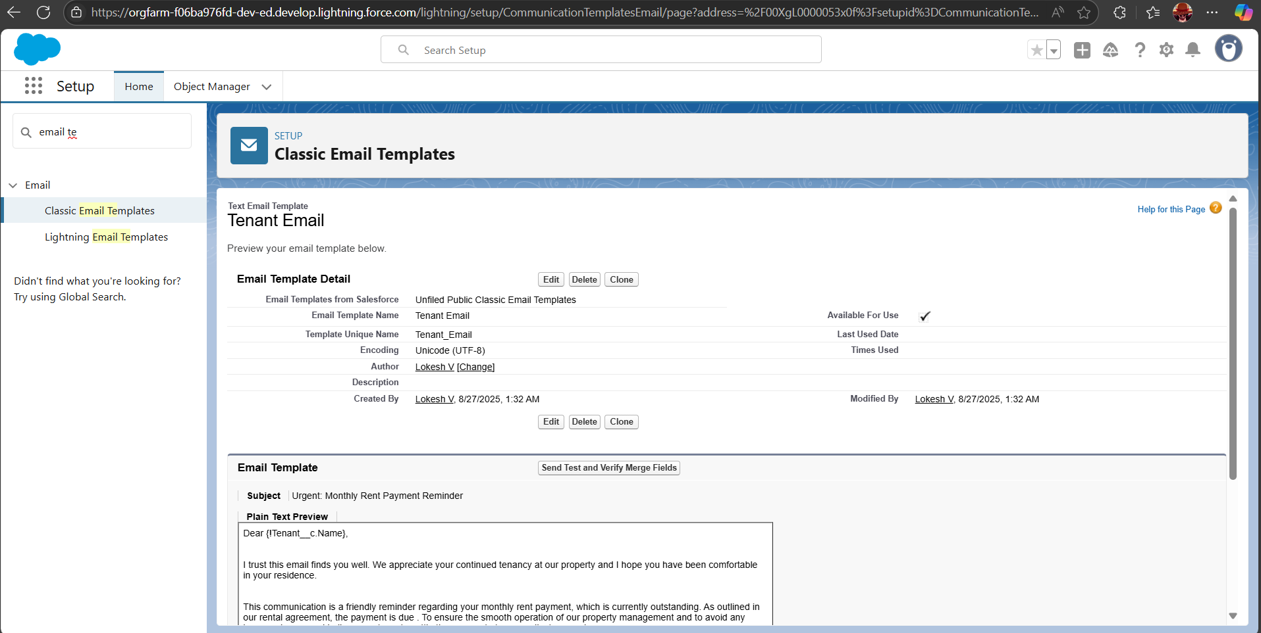

Monthly Payment

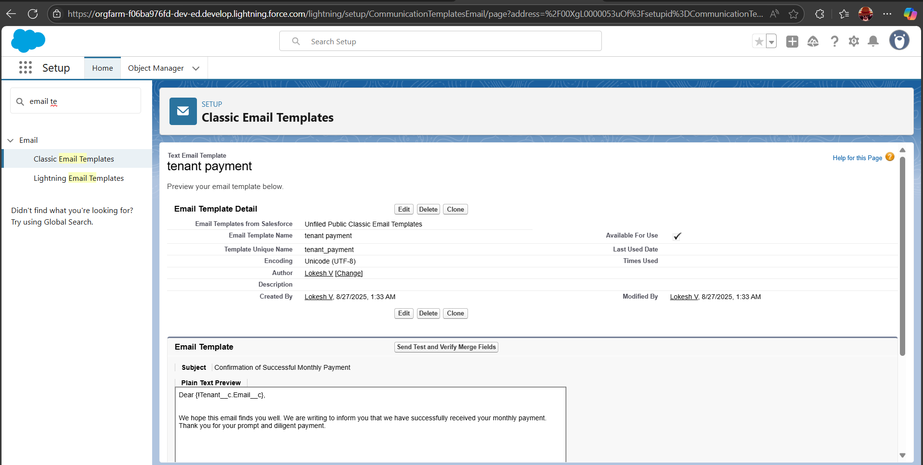

Successful Payment

Approval Process:

Create approval process for check for vacant.

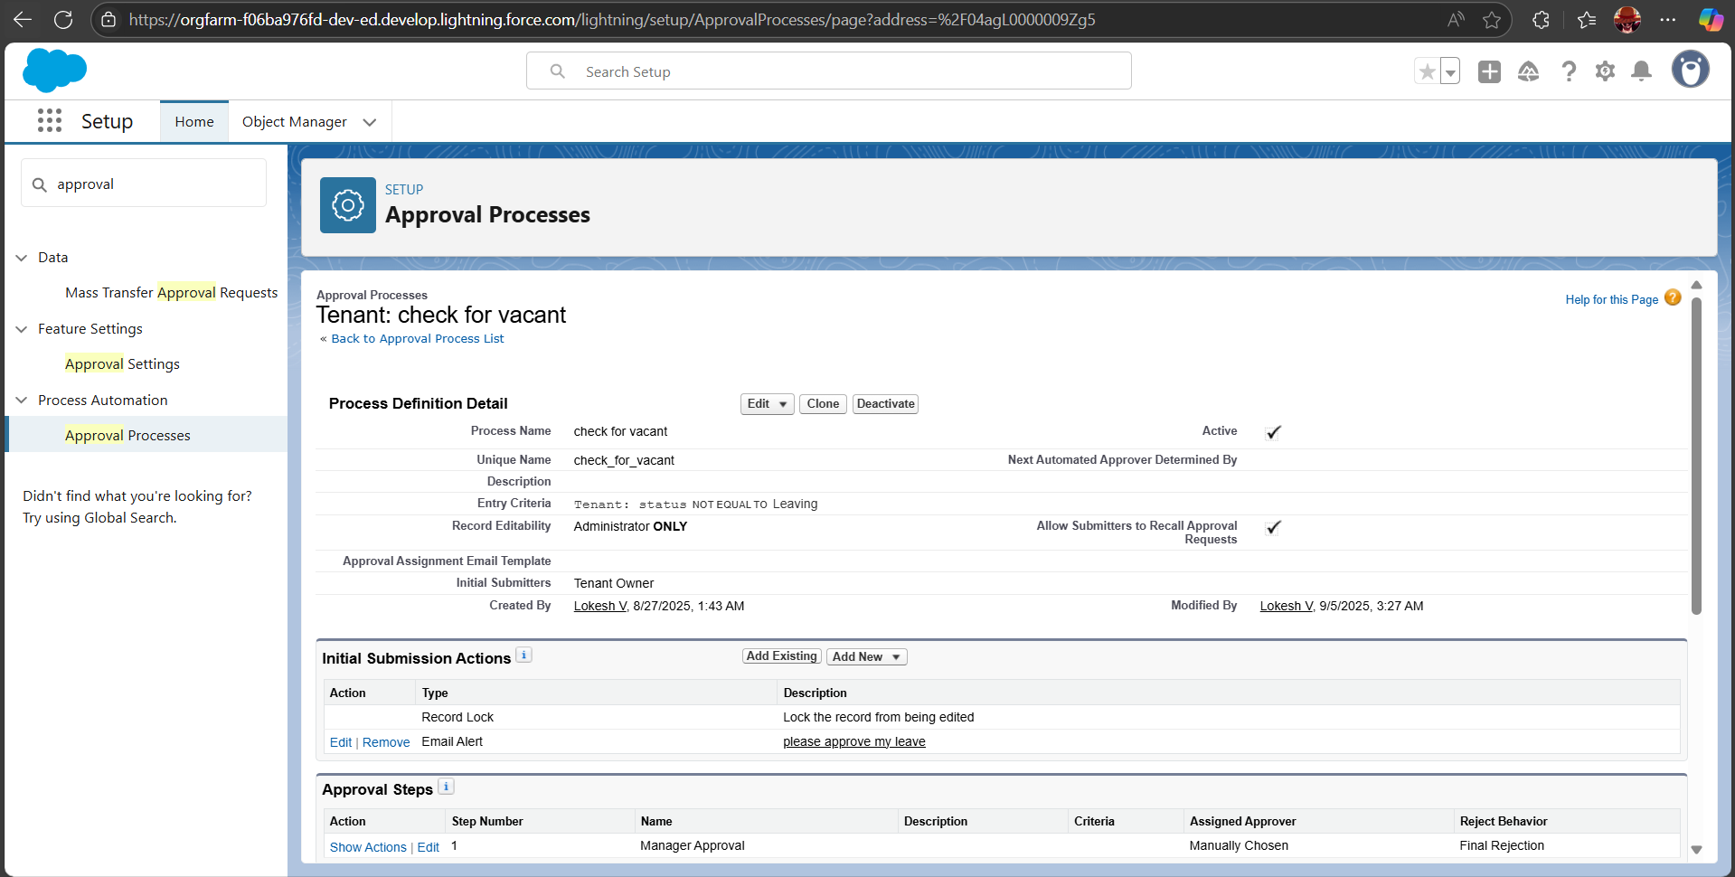

* Created approval actions in the check for tenant.

1. Initial Submission Actions.
2. Final Approval Actions.
3. Final Rejection Actions.

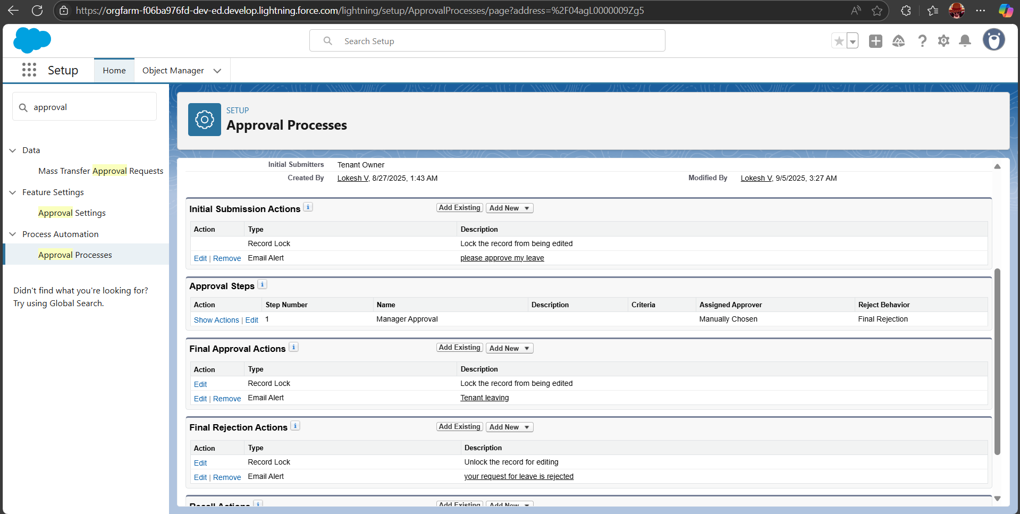

Apex Trigger:

* Create an Apex Trigger and name as “test”.

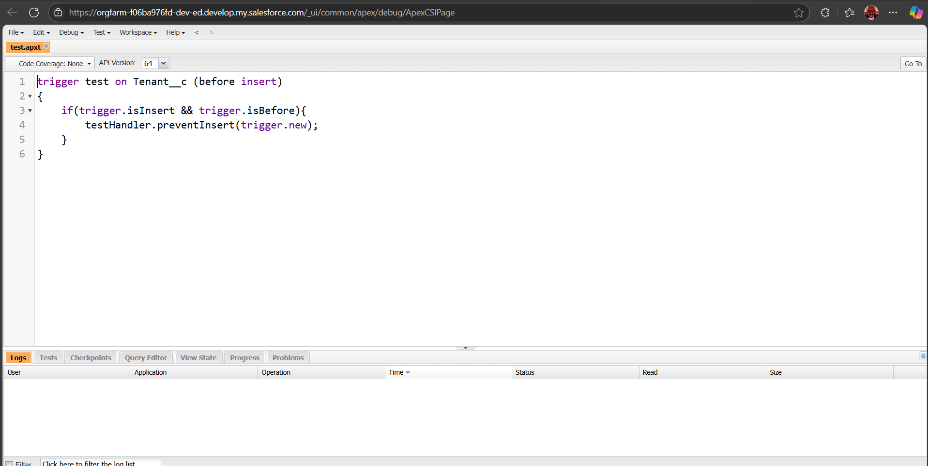

* Create an Apex Class and name as “testHandler”.

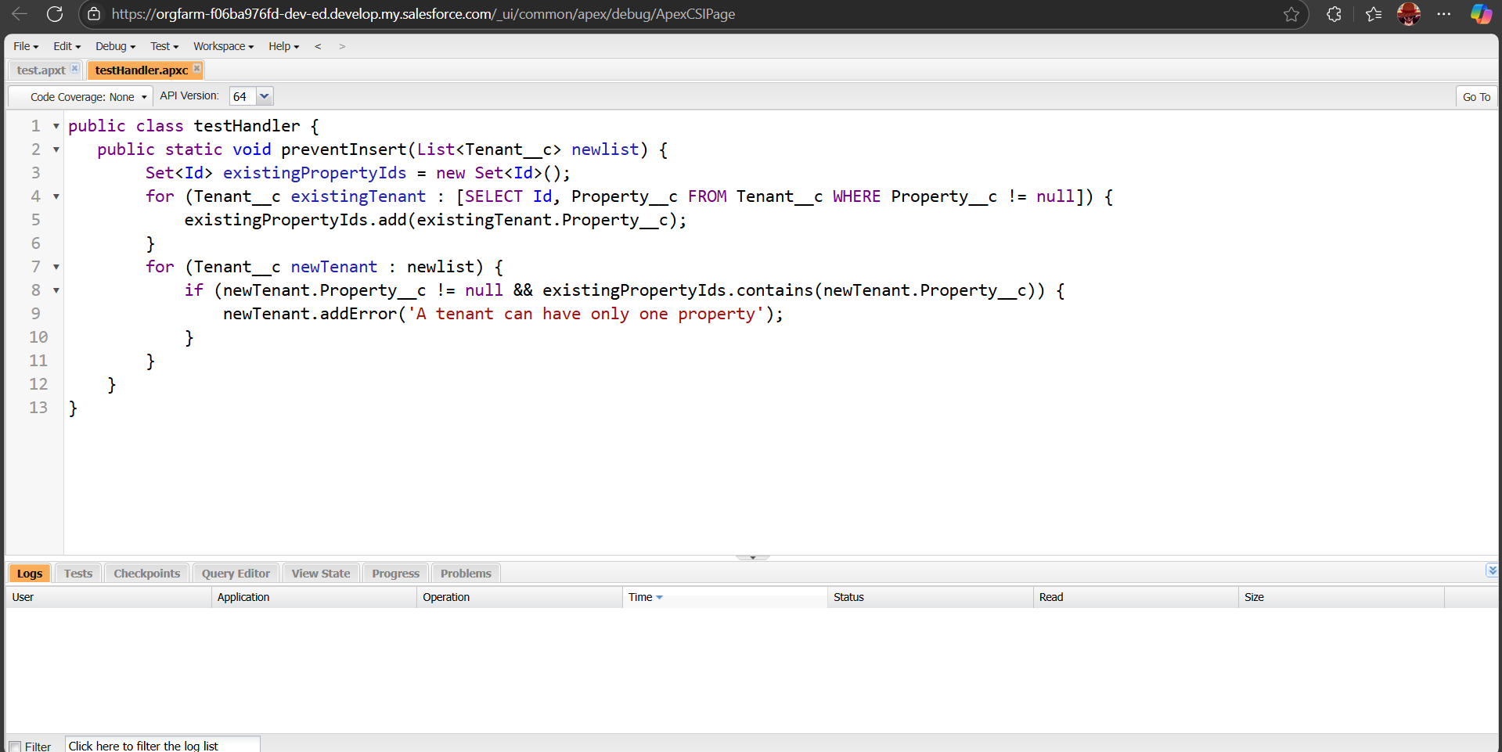

* Testing the trigger to check existing property.

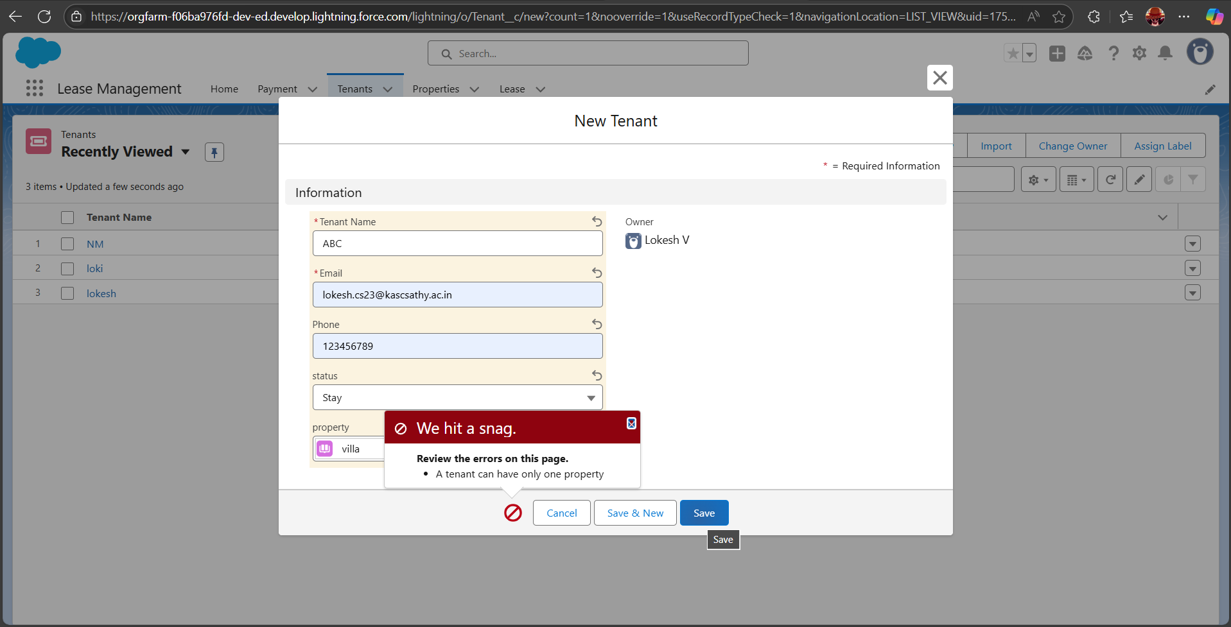

Flows:

* Create a record trigger flow and name as “Monthly Payment”.

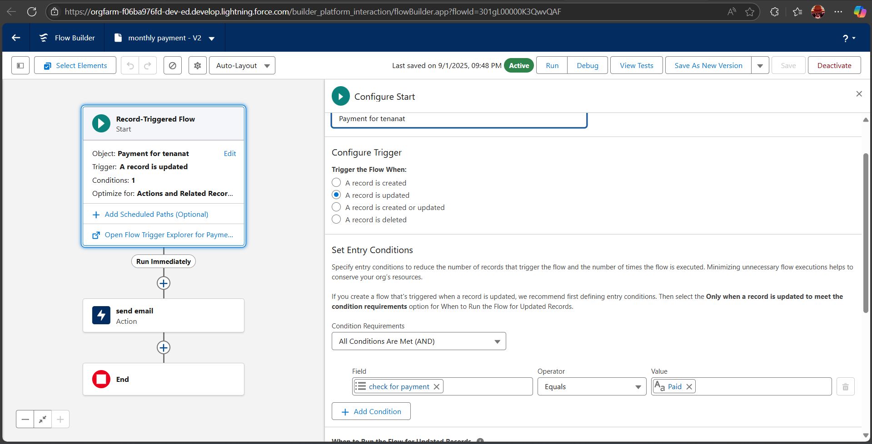

* Create an action in the monthly payment flows name the action as “send email”.

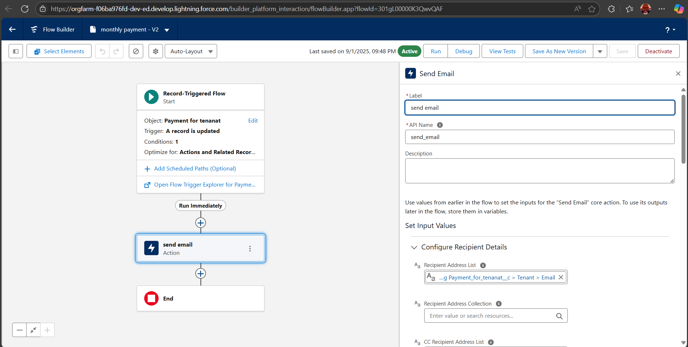

Schedule Class:

* Create an Apex class name as “MonthlyEmailScheduler”.

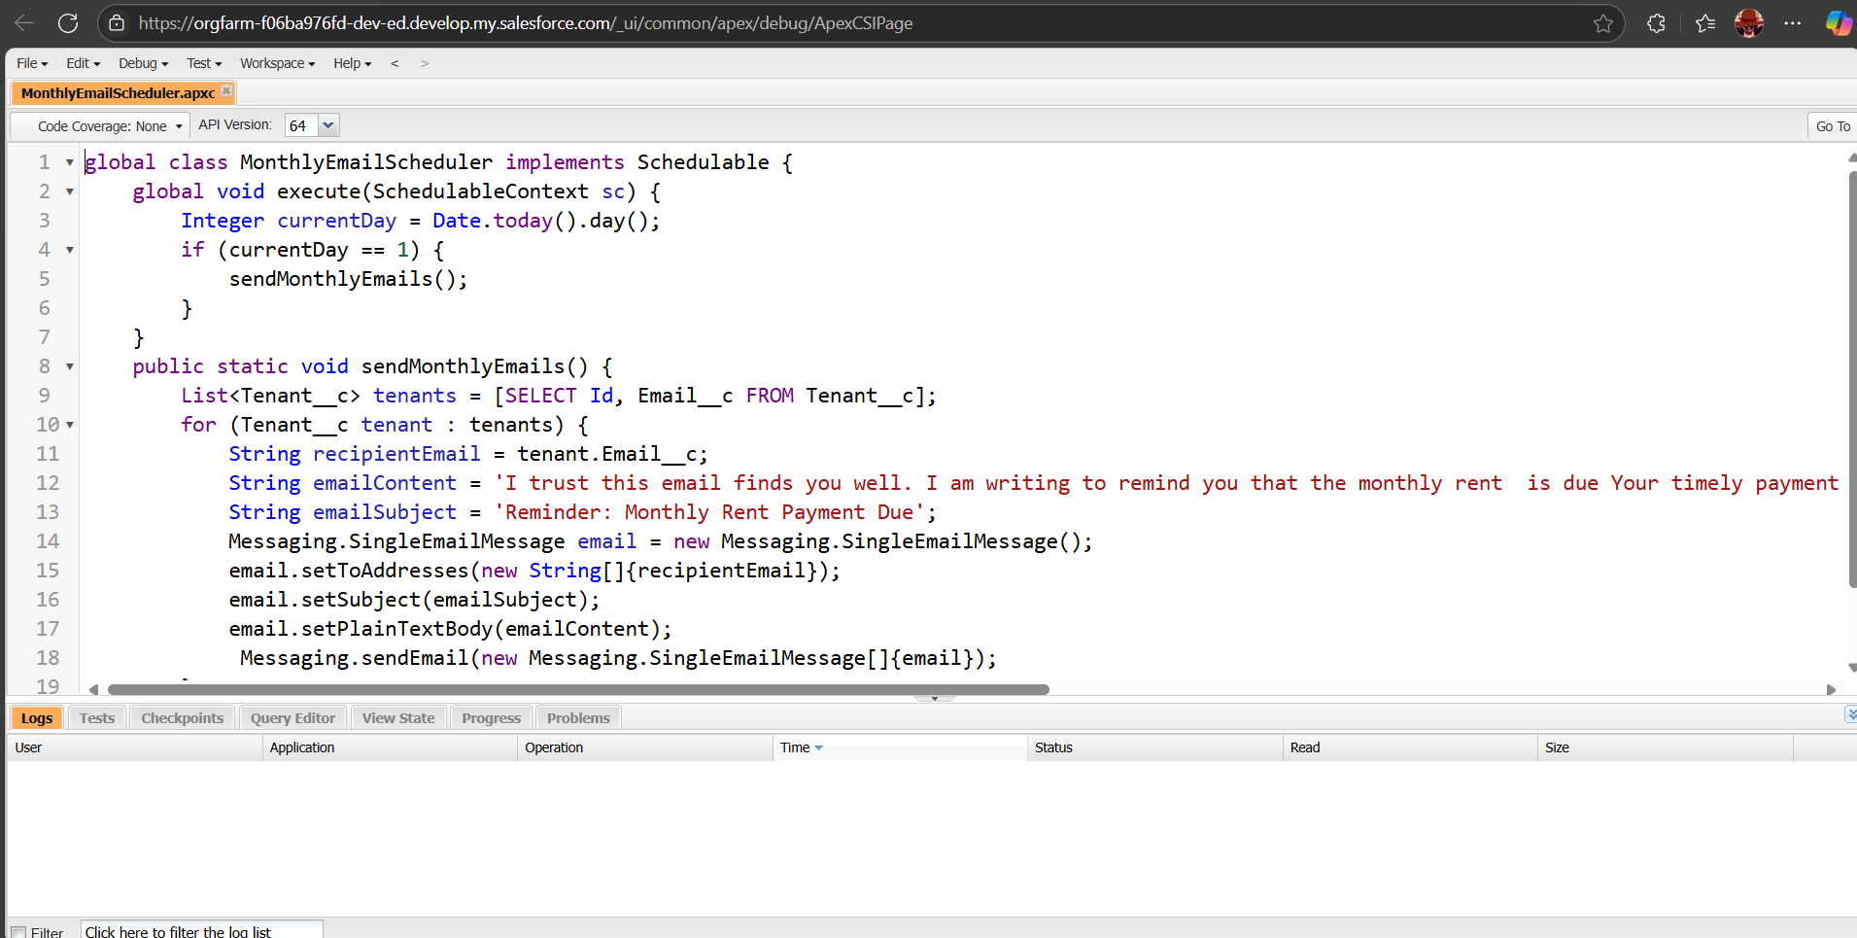

* Create an Apex Schedule class name as “MonthlyEmailScheduler” but I already created and assign in the MonthlyEmailScheduler Class.

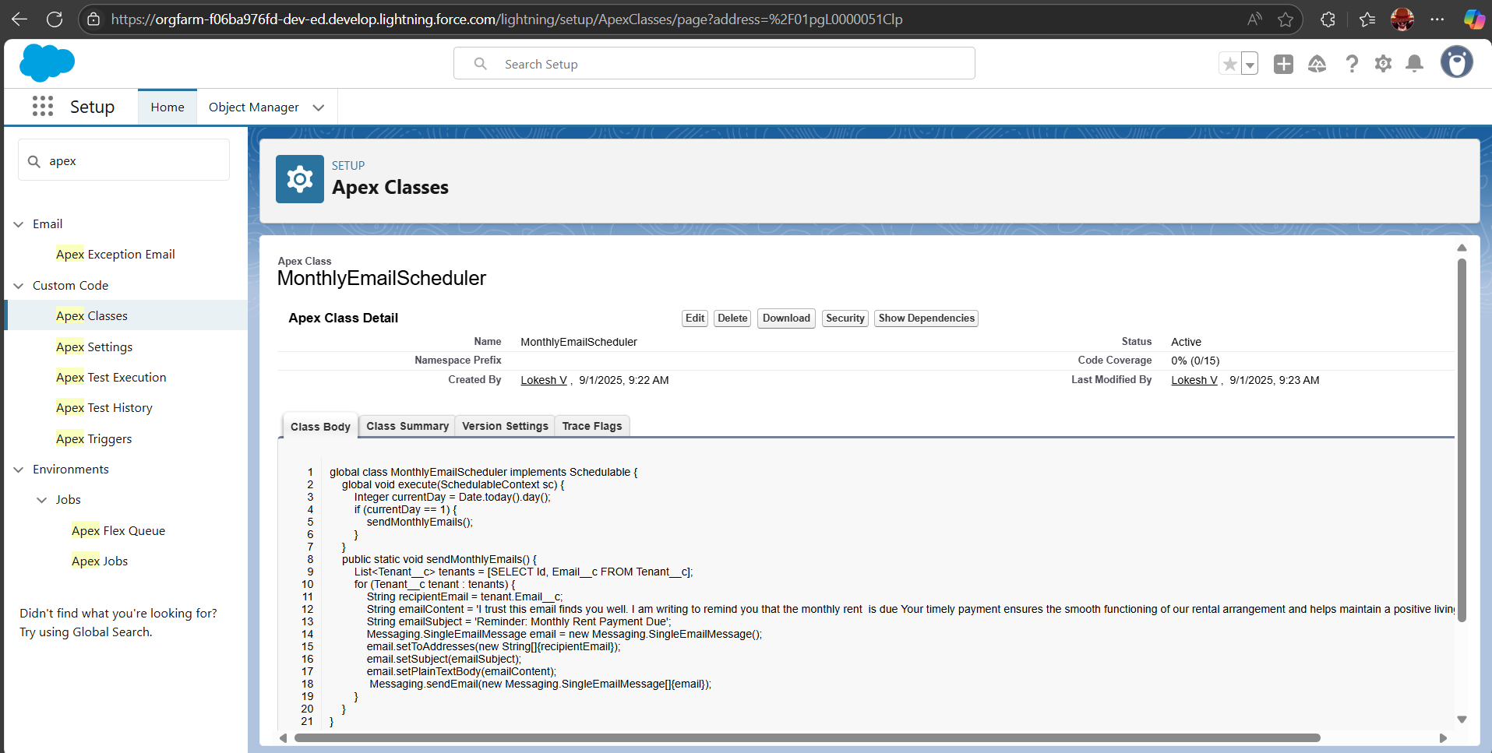

* Testing the Approval Process

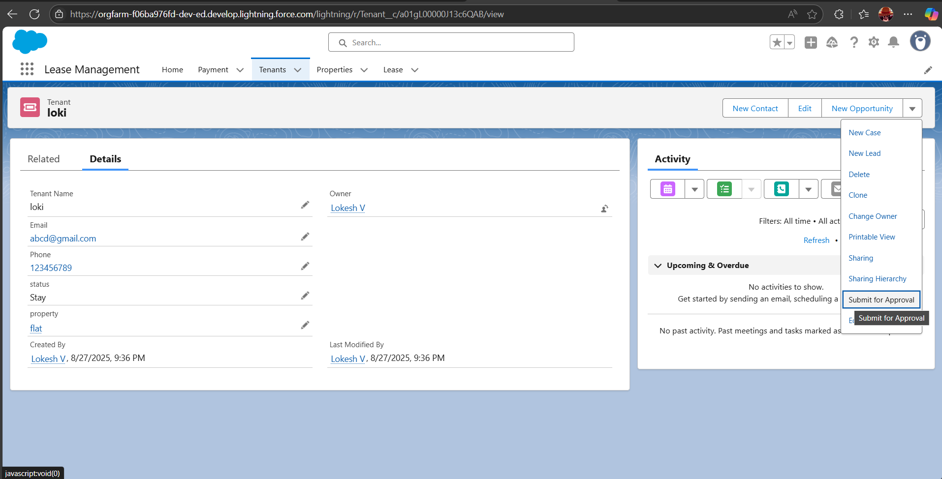

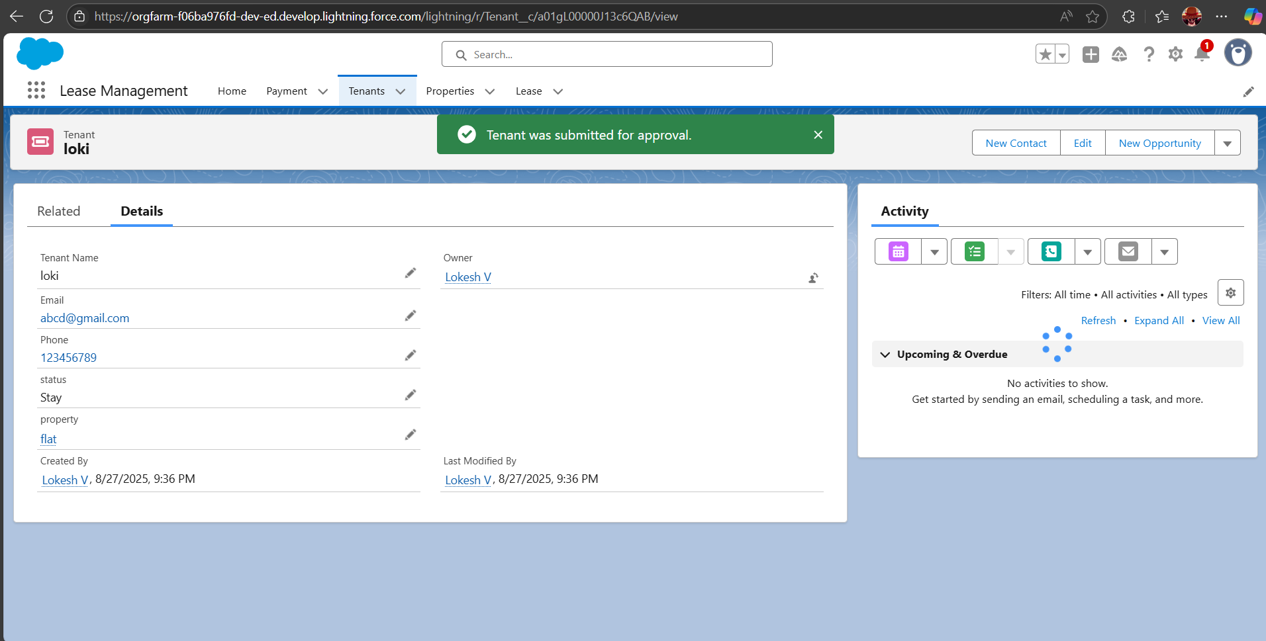

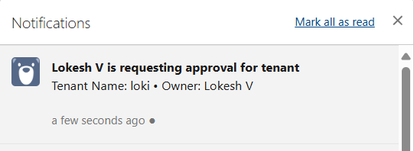

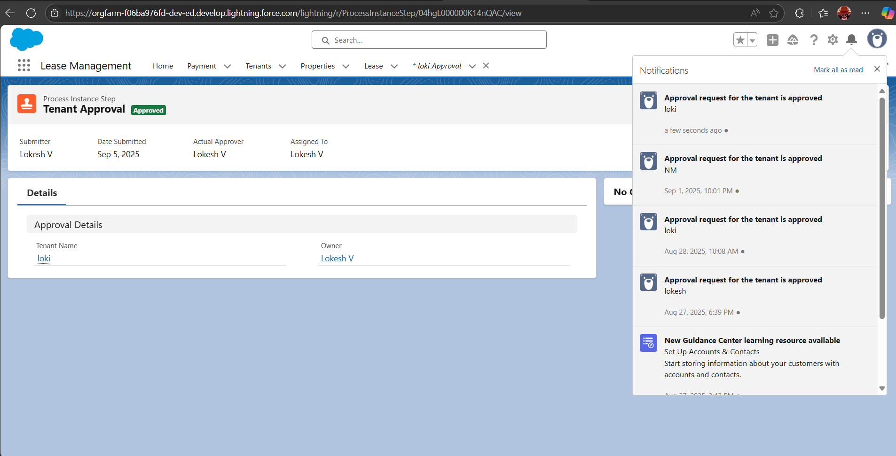

FUNCTIONAL AND PERFORMANCE TESTING

Performance Testing

* Validation Rule Test

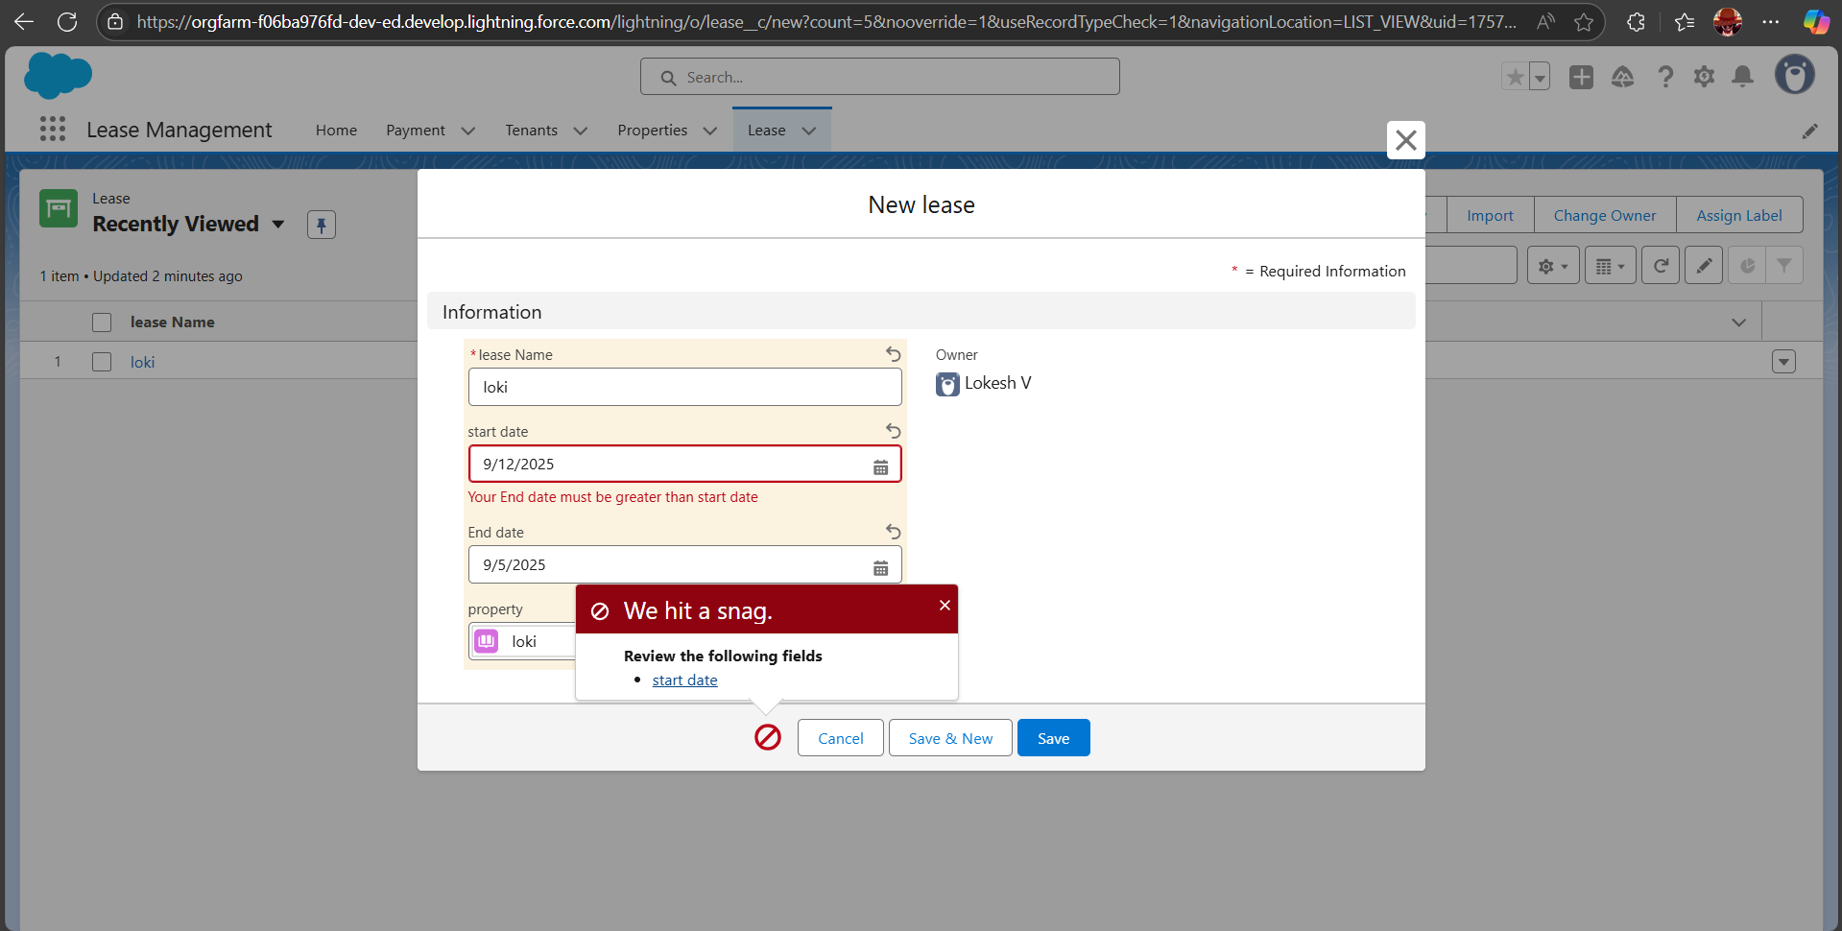

* Testing trigger by entering duplicate tenant - property records.

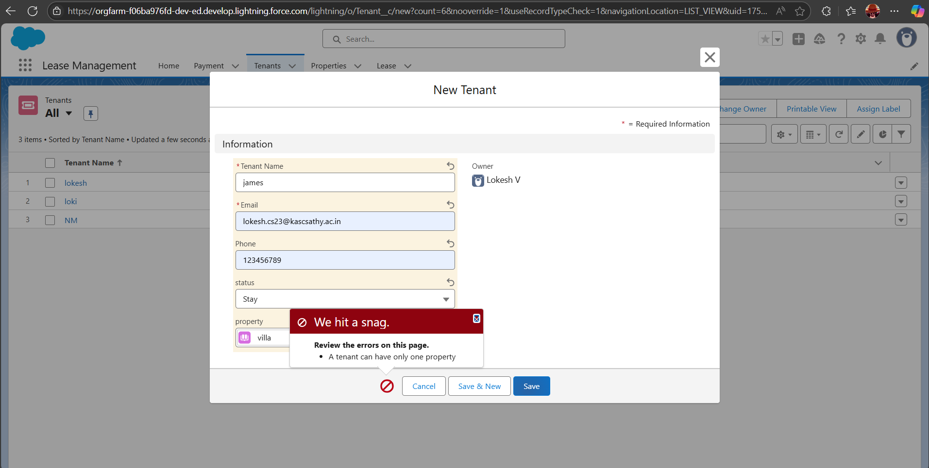

* Approval process validated or approved through via notification and email.

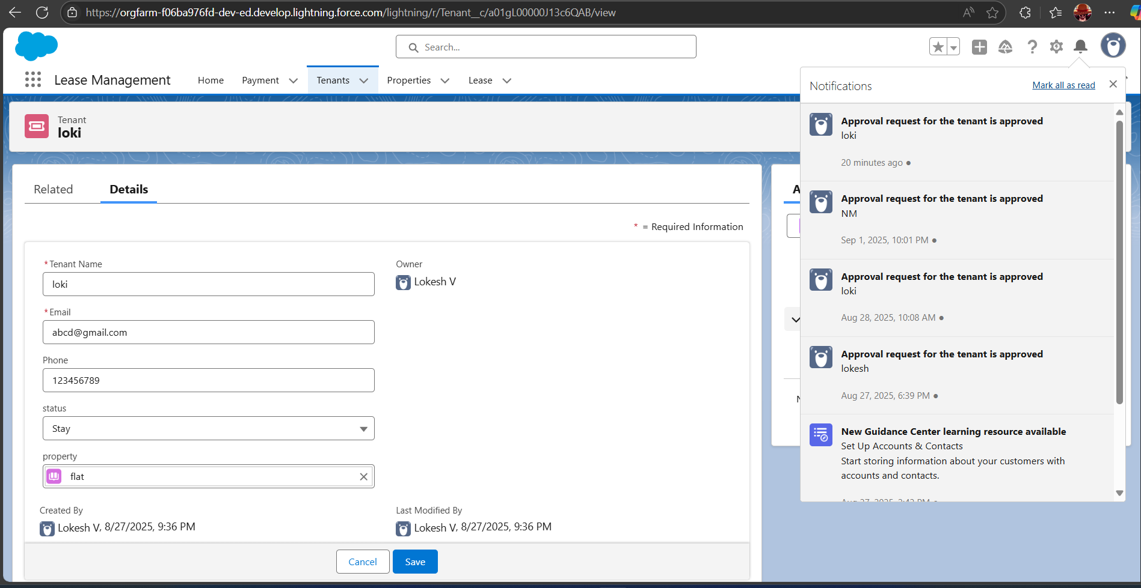

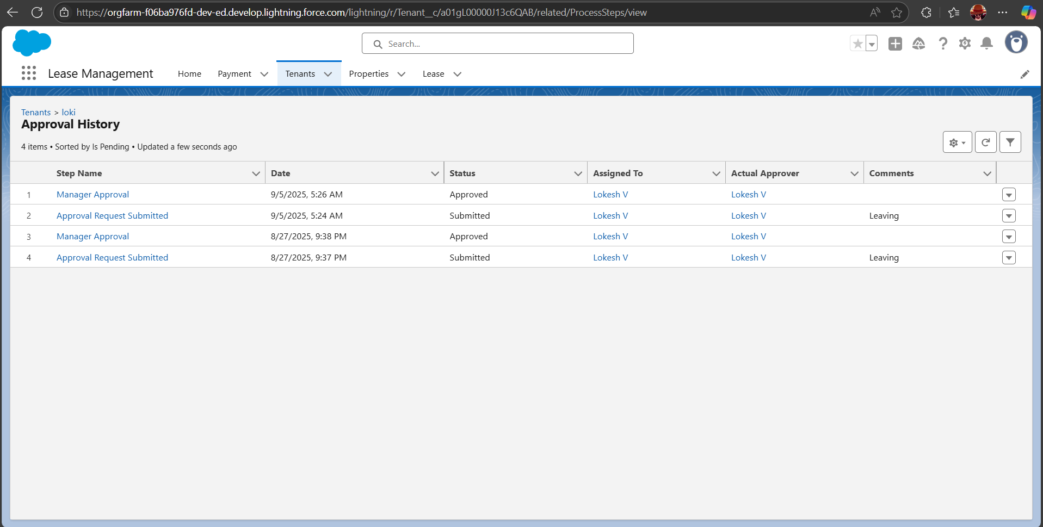

RESULTS

Output Screenshots:

* Email Alerts



* request for approve the leave

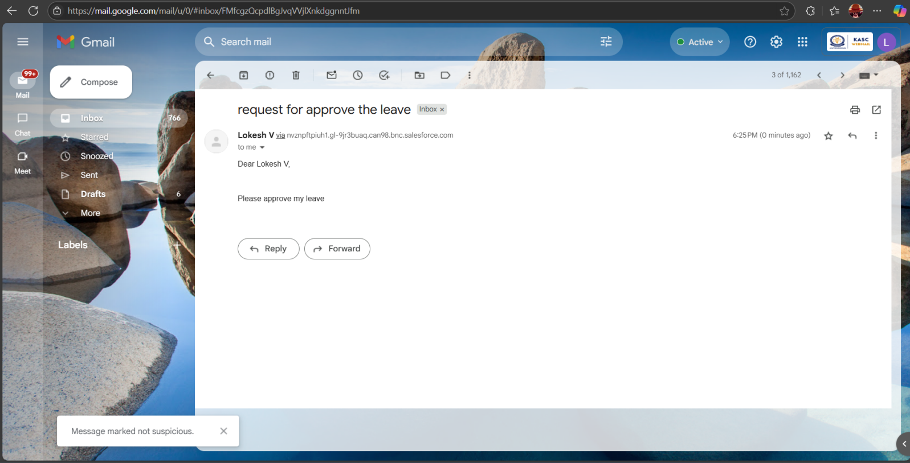

* Approval Request

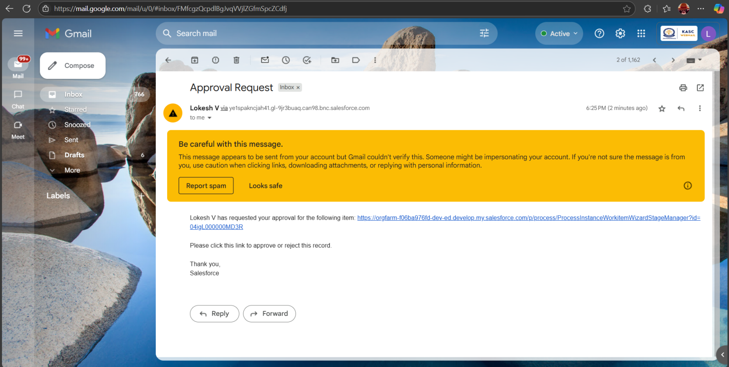

* Leave approved

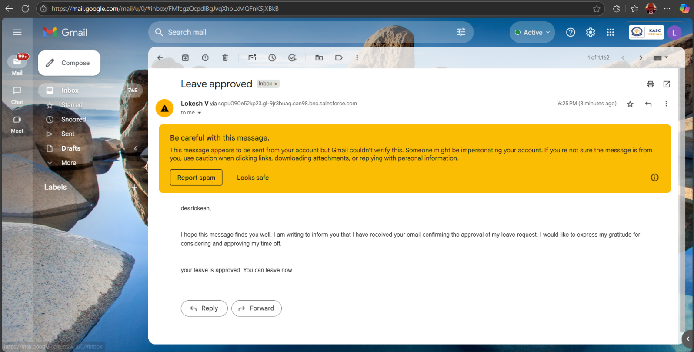

* Leave Rejected

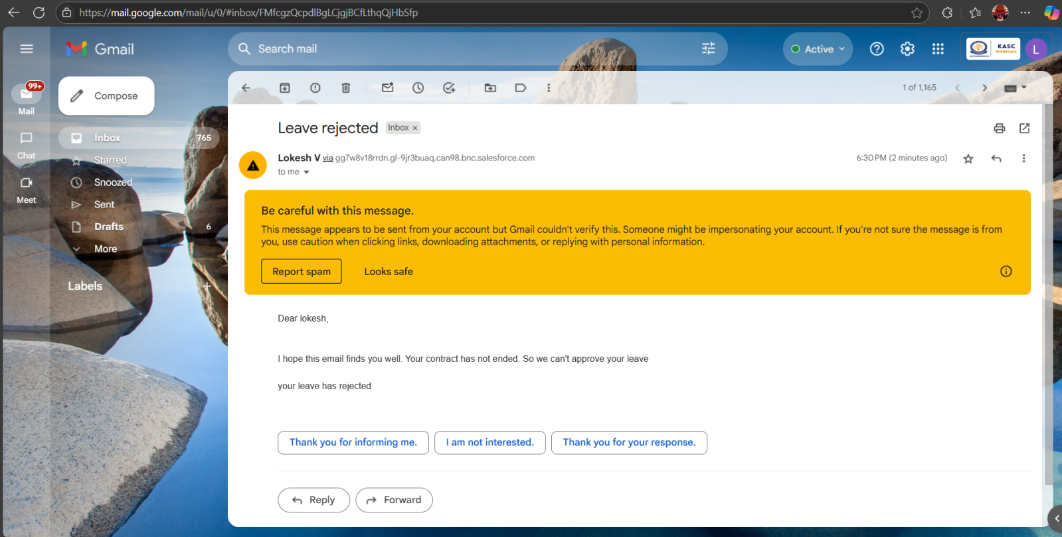

* Approval requests via Notification.

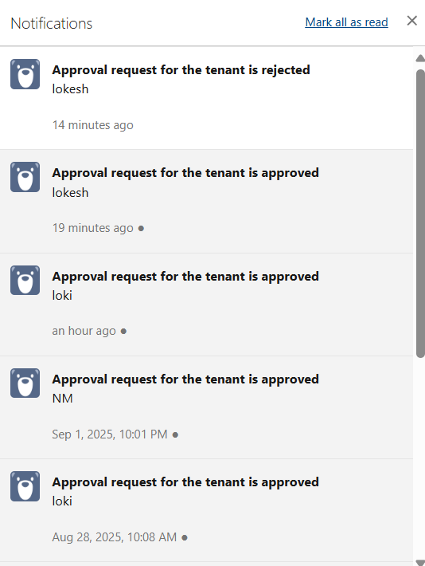

Conclusion:

The Lease Management System, built on Salesforce, streamlines the end-to-end leasing process by automating tasks, reducing manual errors, and enhancing communication between tenants and administrators. This results in improved operational efficiency, better data accuracy, and a more organized approach to lease management.



APPENDIX

* Source Code: Provided in Apex Classes and Triggers

Test.aptx:

trigger test on Tenant__c (before insert)

{

if(trigger.isInsert && trigger.isBefore){

testHandler.preventInsert(trigger.new);

}

}

testHandler.apcx

public class testHandler {

public static void preventInsert(List<Tenant__c> newlist) {

Set<Id> existingPropertyIds = new Set<Id>();

for (Tenant__c existingTenant : [SELECT Id, Property__c FROM Tenant__c WHERE Property__c != null]) {

existingPropertyIds.add(existingTenant.Property__c);

}

for (Tenant__c newTenant : newlist) {

if (newTenant.Property__c != null && existingPropertyIds.contains(newTenant.Property__c)) {

newTenant.addError('A tenant can have only one property');

}

}

}

}

MonthlyEmailScheduler.apxc:

global class MonthlyEmailScheduler implements Schedulable {

global void execute(SchedulableContext sc) {

Integer currentDay = Date.today().day();

if (currentDay == 1) {

sendMonthlyEmails();

}

}

public static void sendMonthlyEmails() {

List<Tenant__c> tenants = [SELECT Id, Email__c FROM Tenant__c];

for (Tenant__c tenant : tenants) {

String recipientEmail = tenant.Email__c;

String emailContent = 'I trust this email finds you well. I am writing to remind you that the monthly rent is due Your timely payment ensures the smooth functioning of our rental arrangement and helps maintain a positive living environment for all.';

String emailSubject = 'Reminder: Monthly Rent Payment Due';

Messaging.SingleEmailMessage email = new Messaging.SingleEmailMessage();

email.setToAddresses(new String[]{recipientEmail});

email.setSubject(emailSubject);

email.setPlainTextBody(emailContent);

Messaging.sendEmail(new Messaging.SingleEmailMessage[]{email});

}

}

}